**ABSTRACT**

This project is focusing on creating a chatbot to be used by students to get their queries responded easily from the college website. The College Enquiry Chatbot has the capacity to make friendly conversations; respond the course and faculty details; give the link for the academic calendar; answer the frequently asked questions. The future work include training the chatbot with more varied data; increasing the scope of the chatbot by adding a speech recognition feature so that users can speak to get responses; and including integration with multiple channels such as phone call, SMS, and various social media platforms.

**ACKNOWLEDGEMENT**

We, the developers of web application “**Collage Enquiry Chatbot**”, with immense pleasure and commitment would like to present the project assignment. The development of this project has given us wide opportunity to think, implement and interact with various aspects of management skills as well as the as the new emerging technologies.

Every work that one completes successfully stands on the constant encouragement, good will and support of the people around. We hereby avail this opportunity to express our gratitude to number of people who extended their valuable time, full support and cooperation in developing the project.

We express deep sense of gratitude towards our Head of the IT Department, Dr. Amit Nayak and project guide Prof. Radhika Patel for the support during the whole session of study and development. It is because of them, that We was prompted to do hard work, adopting new technologies.

We are sincerely thankful to all the people who helped us to complete the project in one way or the other. They altogether provide us favourable environment, and without them it would not have been possible to achieve our goal.

  Yours thankfully,

Preshna Patel

Riya Patel

**TABLE OF CONTENTS**

Abstarct iv

Acknowledgement v

Chapter 1 Project Definition 08

Chapter 2 Description 10

Chapter 3 Software and Hardware Requirement 14

Chapter 4 Major Functionality 16

Chapter 5 System Flow Chart 18

Chapter 6 Screenshot of Project 20

Chapter 7 Project Outcomes 24

Chapter 8 Future Enhancements 26

Chapter 9 References 28

# 

**LIST OF FIGURES**

2.2 Gantt Chart 13

5.1 Flow Chart 19

6.1 Home Page 21

6.2 Home Page 21

6.3 Chatbot 221

6.4 Interacting With Chatbot 212

6.5 Getting Answer from Chatbot 213

**CHAPTER 1: PROJECT DEFINITION**

The “**college enquiry chatbot”** project is developed exploitation algorithms that analyze user queries and understand user message. This method is a web application that provides answers to the student's question. Students would really like simply question through the bot. The program analyzes the user's query and answer.

**CHAPTER 2: DESCRIPTION**

The college bot project is built using artificial algorithms that analyses user’s queries and understand user’s message. This system is a web application which provides answer to the query of the student. Students just have to query through the bot which is used for chatting. Students can chat using any format there is no specific format the user has to follow. The system uses built in artificial intelligence to answer the query. The answers are appropriate what the user queries. The User can query any college related activities through the system. The user does not have to personally go to the college for enquiry. The system analyses the question and then answers to the user. The system answers to the query as if it is answered by the person. With the help of artificial intelligence, the system answers the query asked by the students. The system replies using an effective Graphical user interface which implies that as if a real person is talking to the user.

**2.1 PROJECT PLANNING**

Planning of the project was carried out for keeping all aspects of training and developing. The training for python development was the requirement. All the learnings and small Tasks performed on python lead to the development of this project.

**1.     Prerequisites:**The Python project needs a basic understanding of Python programming and the Flask module.

**2.     Requirement gathering techniques used:**

* Data Gathering: We have referred various sites for collecting relevant pictures and information associated with introducing novelty in updated version of chatbot.
* Group Discussion & Brain-Storming: Discussed the new features that are to be introduced. Analysing current chatbots took ideas from the existing chatbots and upgraded attributes to be added.

**3.     Feasibility study:** Feasibility is the study of impact, which happens in the organization by the development of a system. The impact can be either positive or negative. When the positives nominate the negatives, then the system is considered feasible.

**2.2 GANTT CHART**

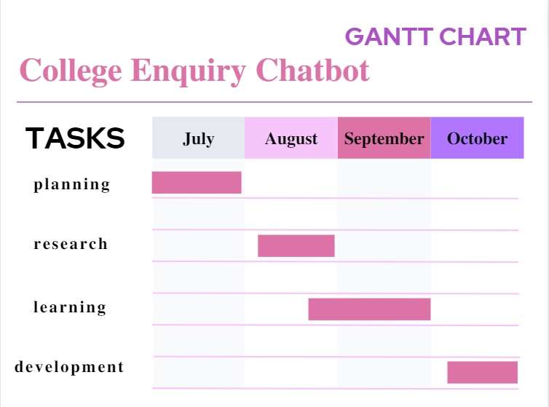

Figure 1 : Gantt Chart

**CHAPTER 3: SOFTWARE AND HARDWARE SPECIFICATIONS**

**Software Requirement:**

•PyCharm / VS code

 

PyCharm VS Code

**Hardware Requirement:**

•Laptop/pc

•Memory: 4GB RAM

•Processor : i5 / i7

•Operating system: windows 10

**Language used:**

•Python , AI, JavaScript

**CHAPTER 4: MAJOR FUNCTIONALITY**

* The user can query about the college related activities through online with the help of this web application.
* User can enquire about facilities and query related to admissions, fees.
* Users can also ask questions related to placement activities.

**CHAPTER 5: SYSTEM FLOW CHART**

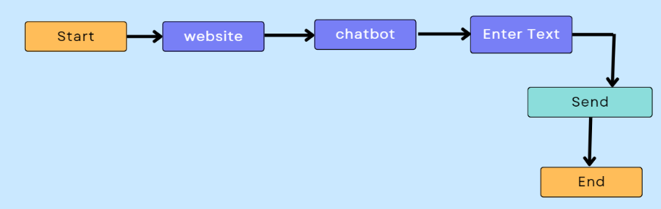

Figure 2 : Flow Chart

**CHAPTER 6: SCREENSHOTS OF YOUR PROJECT OUTPUT**

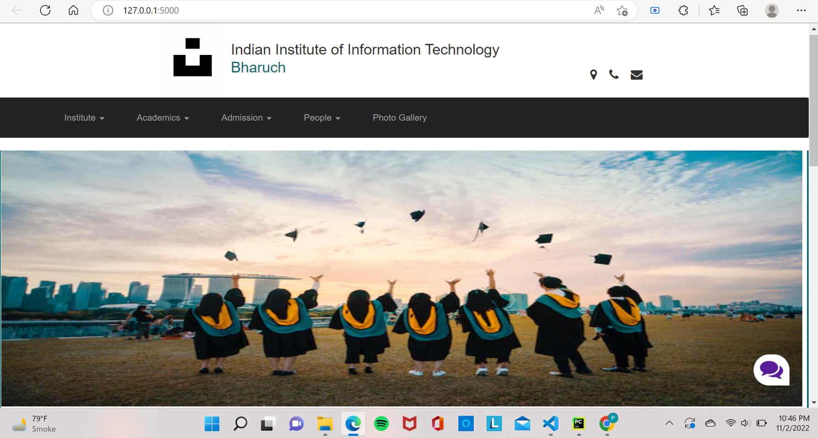

Figure 3: Home Page

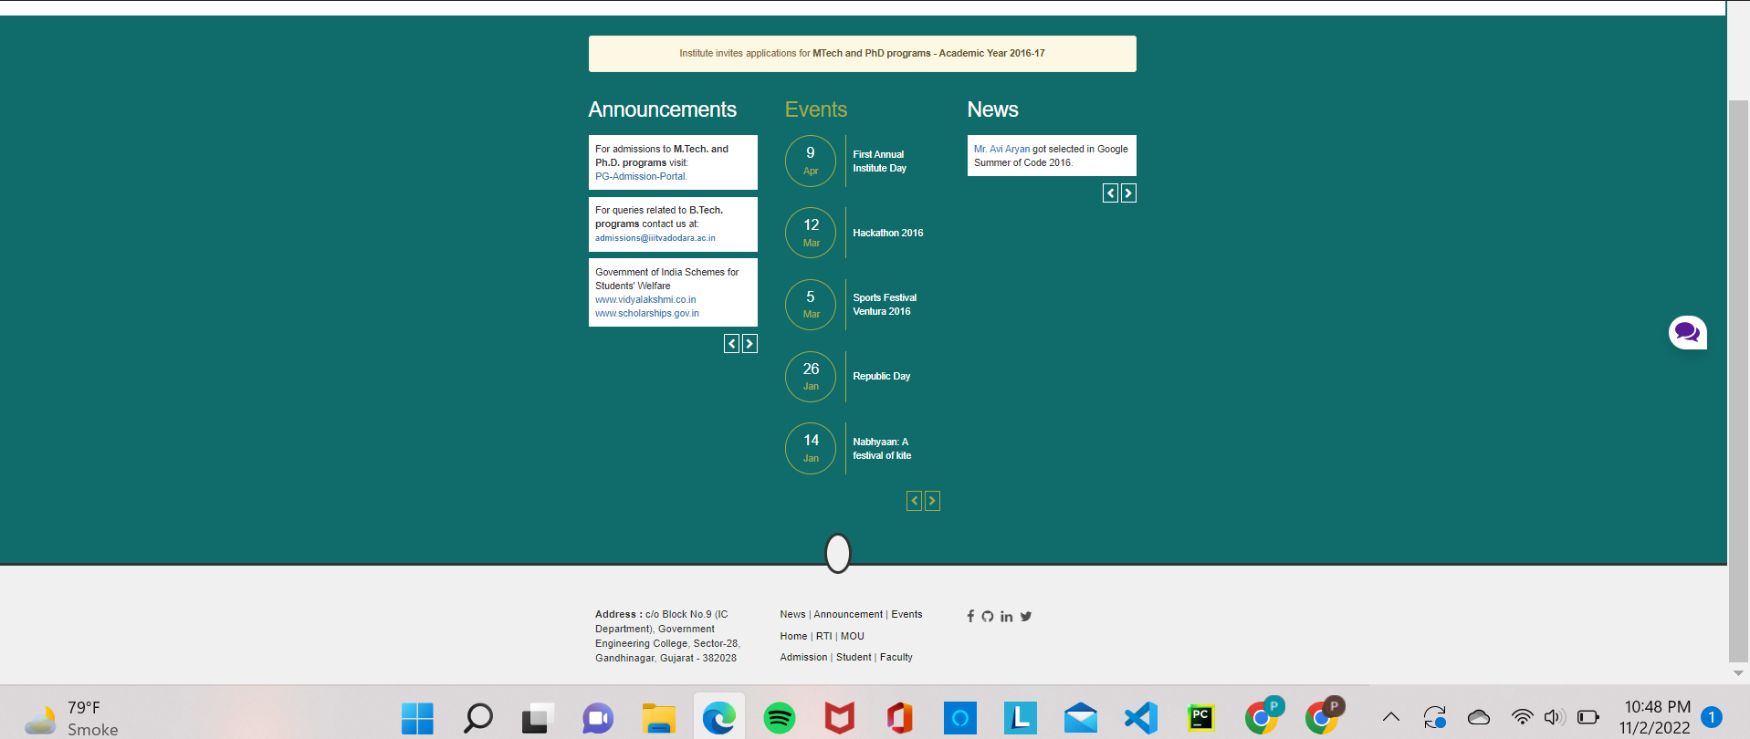

Figure 4: Home Page

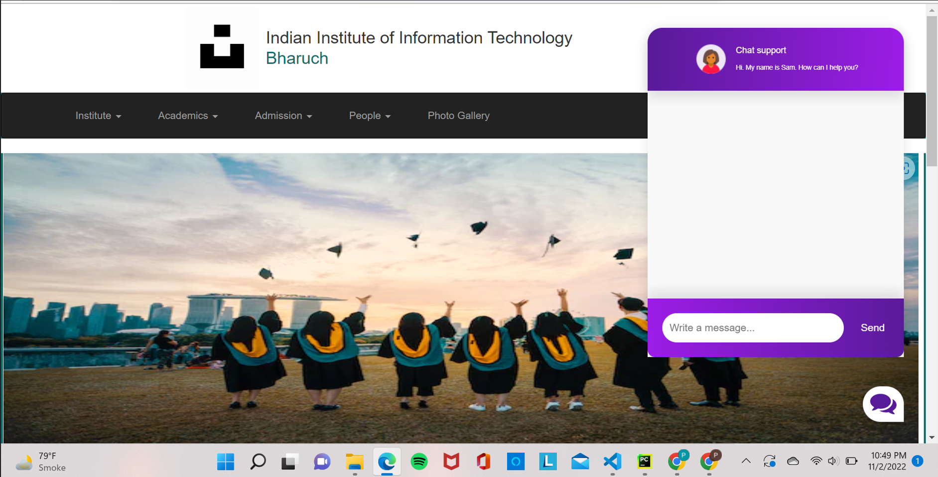

Figure 5: Chatbot

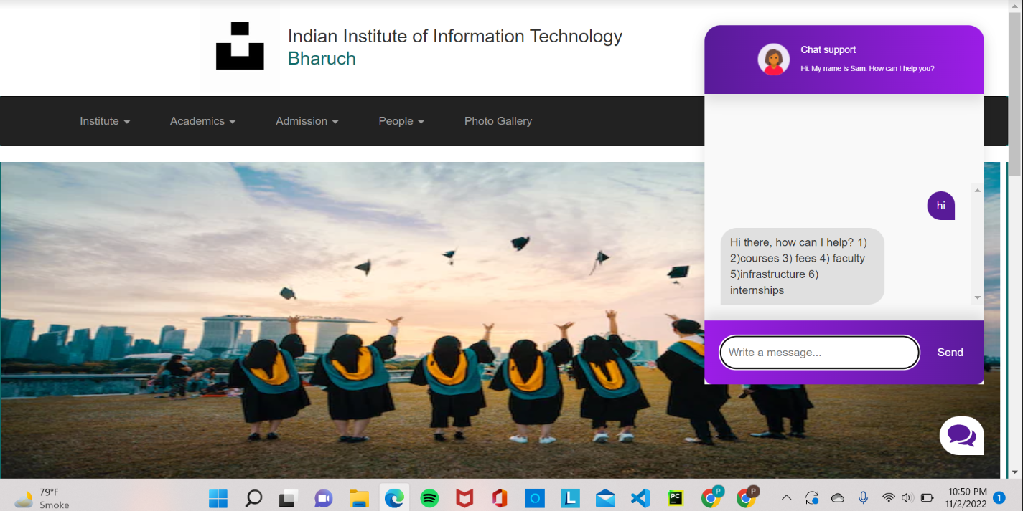

Figure 6: Interacting with Chatbot

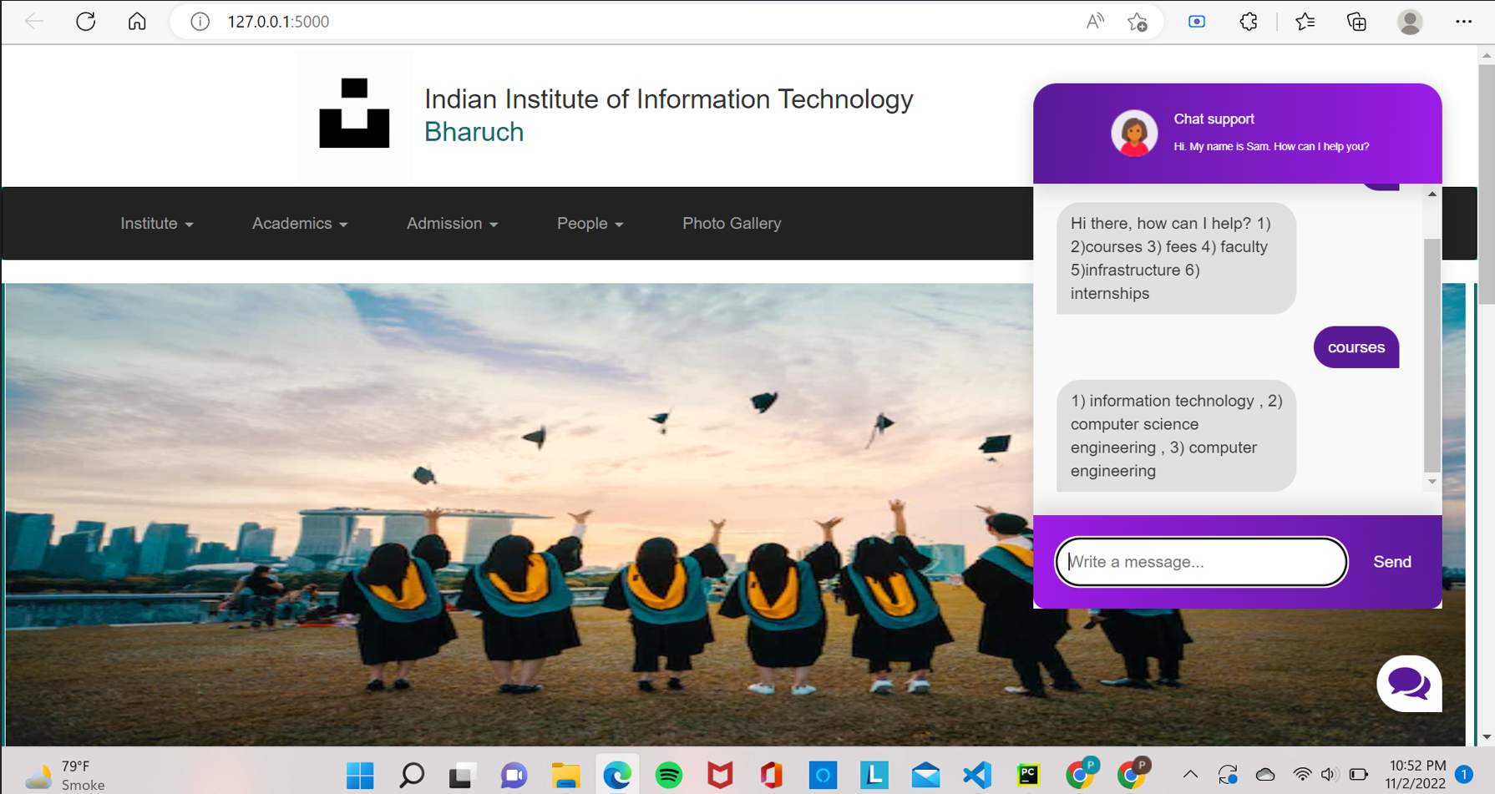

Figure 7: Receiving Answers from Chatbot

**CHAPTER 7: PROJECT OUTCOME**

* “Collage Enquiry Chatbot” saves time for users.
* Easy interaction on chatbot when needed any help.
* This project is focusing on creating a chatbot that provides User friendly interface.
* User do not have to do registration and login process so, doesn’t take much time.

**CHAPTER 8: FUTURE ENHANCEMENTS**

We can include speech-based questions and responses. The users just need to provide voice-based input and the developed bot will provide the text-based output and while giving it, it will provide a voice-based output as well.

**CHAPTER 9: REFERENCES**

1. **Python Flask tutorials:** <https://youtu.be/oA8brF3w5XQ>
2. **Python tutorials:** <https://youtu.be/gfDE2a7MKjA>
3. **Python JSON tutorials:** <https://www.w3schools.com/python/python_json.asp>
4. **JavaScript tutorials:** <https://youtu.be/IC5vBKc21X8>
5. **Html, CSS, bootstrap tutorials:** <https://youtube.com/playlist?list=PLd3UqWTnYXOnHZNpQwS0dBs_elseOuPVB>